User Requirements Specifications



**Date:** 09/09/2020

**Location:** Rachelsmolen 1, 5612 MA Eindhoven

**Members:**

Tsanko Nedelchev (Team leader)

Rick van Ham

Menderes Saçli

Loek Hamers

**Tutor:** Gupta,Roopali R.

# 

Version Control

# 

|  |  |  |
| --- | --- | --- |
| **Version** | **Editors** | **Changes** |
| **1.0** | Loek Hamers, Menderes Sacli, Rick van Ham | Made the first version of the URS. |
| **1.1** | Loek Hamers, Menderes Sacli, Rick van Ham, Tsanko Nedelchev | Processing feedback, Adding and editing use cases, adding more GUI sketches. Added version Control. Adding UML Class Diagram and Database-Design. |
| **1.2** | Loek Hamers, Menderes Sacli, Rick van Ham, Tsanko Nedelchev | Processing feedback, Adding and editing use cases, adding more GUI sketches, Updating the UML Class Diagram and Database-design. |
| **1.3** | Loek Hamers, Menderes Sacli, Rick van Ham, Tsanko Nedelchev | Processing feedback, Adding and editing use cases, adding Functional Requirements, updating MoSCoW, Improving and adding GUI’s, Updating UML Class Diagram and ERD-design. |
| **1.4** | Loek Hamers, Menderes Sacli, Rick van Ham, Tsanko Nedelchev | Minor changes to formating, fixed the Contents section, updated UML and ERD |

# 

Contents

Introduction 4

Objectives 4

Scope 4

Client Agreements 5

Functional Requirements 6

MoSCoW 7

Use Cases 8

GUI 14

UML Class-Diagram 19

ERD 20

# Introduction

## Objectives

This is the User Requirements Specifications document for the “Media Bazaar” project, for use by Team B.R.U.H.  
  
The User Requirements Specifications for Team B.R.U.H will describe the business needs and requirements for the application. These requirements will assure that Team B.R.U.H will correctly and reliably perform its intended functionality.

## Scope

The main objective of this software is storing information of employees and products within the database. This data is used to keep track of all products and employees within the Media Bazaar store, employee working schedules included. This makes the process of running the business more lucid for the employees and the manager. Managers get a higher ranking than the employees, with more possibilities, which means every employee gets a unique account with a password.

# Client Agreements

|  |  |
| --- | --- |
| **Topics** | **Client agreement** |
| **Form of the product** | The client agreed that for Phase 1, we would deliver the product in the form of a desktop application. The product will extend to a web application if the desktop application is a success. |
| **Focus of the product** | The client agreed that the focus for now should be on the employees and the stock. |
| **Accessible to the**  **product** | The client agreed that for now, the product should be manager accessed only, meaning only the manager can use it. In further phases, other users will be added such as employees and salesman per departement. |
| **Data of the product** | The client agreed that employees data should contain their personal data, like: name, address and departement, and their time of arrival and departure.  And the stock data should contain their information and the categories they belong to.  The client also agreed that only the management can alternate the employees’ data and the employee of stocks can alternate the stocks’ data. |
| **Layout** | The client agreed that we, as a company, get to choose what the layout looks like. |

# Functional Requirements

**FR-01**: Users should be able to keep track of their employees.

C-01.1: Employees can’t keep track of other employees

**FR-02:** All employees should be able to keep track of the stocks.

**FR-03**: Users should be able to assign work-shifts to employees.

C-03.1: A manager can only assign work-shifts to employees.

**FR-04**: Users should be able to remove employees from working shifts.

C-04.1: Only managers can remove employees’ shifts.

**FR-05**: Users should be able to remove employee’s working shifts.

**FR-06**: Users can view assigned working shifts.

**FR-07**: Users can view details of employees

C-07.1: Only managers can view employees’ details.

**FR-08**: Users should be able to add new employees.

C-08.1: Only managers will be able to add employees to the software.

**FR-09**: Users should be able to remove employees.

C-09.1: Only managers will be able to remove employees from the software.

**FR-10**: Users can alter employee’s personal details.

C-10.1: Both the manager and the employee(own details) can alter the employee’s personal details.

**FR-11**: Users must be logged in to use the software.

C-11.1: There are 2 types of accounts; manager and employee.

C-11.2: A manager-account has more permissions than an employee account.

FR-12: Users must be able to request for a re-stock.

C-12.1: Only a manager has the permission to re-stock.

**FR-13**: Users must be able to add a department.

C-13.1: Only a manager can add a department.

**FR-14**: Users must be able to edit a department.

C-14.1: Only a manager can edit a department.

**FR-15**: Users must be able to delete a department.

C-15.1: Only a manager can delete a department.

# MoSCoW

**Must:**

1. The application must be able to give an overview of all employees.
2. Managers can assign working hours to employees.
3. All employees can look at the list of products that are available.
4. All employees can view the working schedules.
5. New employees can be added to the software.
6. Employees can be deleted from the software.
7. Managers must be able to alternate employees’ information.
8. Managers must be able to remove employees’ from a working shift.
9. Managers must be able to search for specific individuals
10. Users have a profile with their personal information and working shifts.
11. The software must give a notification for when the stock drops below a certain point.
12. The manager must be able to send a request to re-stock when the stock is running low.

**Should:**

1. Employees should be able to get soft-deleted from the software, meaning they will still be in the database, but as an ex-employee.
2. Employees should be able to get a status, like: available, unavailable, absent etc.
3. Employees should have a hire date and a leave date.

**Could:**

1. The software could have a dark-mode.
2. The software could make use of colors for easier visibility and a better overview, so employees can see when e.g. someone is blocked on a certain date.

**Won’t:**

# 

# Use Cases

**UC01:** Keeping track of employees. :FR-01

**Actor:** Manager

**Main Success Scenario:**

Actor navigates to the employee list.

System shows a list of employees.

End of use case.

**UC02:** Keeping track of products. :FR-02

**Actor:** Employee

**Main Success Scenario:**

Actor goes to the stock section.

System shows a list of available stock.

End of use case.

**UC03:** Assigning working shifts. :FR-03

**Actor:** Manager

**Pre-condition**: The manager must be logged in to a manager-account.

**Main Success Scenario:**

Actor navigates to the list of employees.

Actor chooses the employee.

System brings up a schedule.

Actor assigns an employee to the chosen date and working hour.

System saves the data.

System shows a notification that changes have been saved.

End of use case.

**Extensions:**

1a: The actor assigned the wrong person.

.1: <<include use case 4>>

.2: End of use case.

2a: The actor assigned the wrong person.

.1: <<Include use case 5>>

.2: End of use case.

**UC04:** Deleting an employee from a shift through the schedule. :FR-04

**Actor:** Manager

**Pre-condition**: The manager must be logged in to a manager-account.

**Pre-condition**: The employee has already been assigned to a working shift.

**Main Success Scenario:**

Actor navigates to the schedule.

Actor chooses to edit a working shift.

System displays specific working shift details.

Actor deletes employee from shift and confirms.

System saves changes made to the shift and shows a message that it has been saved.

End of use case.

**UC05:** Deleting an employee’s shift through the employee profile. :FR-05

**Actor:** Manager

**Pre-condition**: The manager must be logged in to a manager-account.

**Pre-condition**: The employee has already been assigned to a working shift.

**Main Success Scenario:**

Actor picks the employee through the employee list.

System displays that employee’s profile.

Actor navigates to the assigned work shifts part of the profile.

Actor chooses the working shift to remove.

System removes that working shift for that employee.

System saves changes.

System shows a notification that changes have been saved.

End of use case.

**UC06:** View a working shift. :FR-06

**Actor:** Employee

**Pre-condition**: The employee has already been assigned to a working shift.

**Main Success Scenario:**

Actor selects a working shift through the shift timetable.

System displays the chosen working shift and its details(Who works and what time they work)

End of use case.

**UC07:** View an employee’s details. :FR-07

**Actor:** Manager

**Main Success Scenario:**

Actor chooses an individual through the employee list.

System opens up the chosen employees profile.

End of use case.

**UC08:** Adding an employee to the system. :FR-08

**Actor:** Manager

**Pre-condition**: The manager must be logged in to a manager-account.

**Main Success Scenario:**

Actor chooses “Add Employee” in the employee tab.

System displays a page with empty fields.

Actor fills the fields accordingly then confirms.

System saves changes and adds the employee to the system.

System shows a notification that changes have been saved.

End of use case.

**Extensions:**

1a: Actor failed to fill all the required fields.

1. System displays failed requirement message.

2. Return to MSS step 3.

**UC09:** Deleting an employee from the system. :FR-09

**Actor:** Manager

**Pre-condition**: The manager must be logged in to a manager-account.

**Main Success Scenario:**

Actor chooses to view list of employees

System displays a list of all employees.

Actor deletes the selected employee and confirms.

System deletes the employee from the software and saves changes.

System shows a notification that changes have been saved.

End of use case.

**Extensions**:

1a: Actor fails to select an employee.

.1: System gives an error message.

.2: Return to MSS step 3.

**UC10:** Editing an employee's working hours. :FR-10

**Actor:** Manager

**Pre-condition**: The manager must be logged in to a manager-account.

**Pre-condition**: The employee has already been assigned to a working shift.

**Main Success Scenario:**

Actor wants to edit an employee’s shift.

System displays all shifts.

Actor chooses an employee’s shift and confirms.

System displays information about the shift.

Actor updates the shift and confirms.

System saves changes.

System shows a notification that changes have been saved.

End of use case.

**UC11:** Editing an employee's departement. :FR-10

**Actor:** Manager

**Pre-condition**: The manager must be logged in to a manager-account.

**Pre-condition**: The employee has already been assigned to a departement

**Main Success Scenario:**

Actor wants to change an employee’s departement.

System displays all employees.

Actor chooses the specific employee and confirms.

System shows that employee’s information.

Actor updates his departement.

System saves changes.

System shows a notification that changes have been saved.

End of use case.

**UC12:** Requesting to re-stock: FR-12

**Actor**: Manager

**Pre-condition**: The manager must be logged in to a manager-account.

**Pre-condition**: The stock is running too low.

**Main Success Scenario**:

System displays a message with the notification that the stock is running low.

Actor wants to view the list of available stock.

System shows the list of available stock.

Actor picks the product he wants to request a restock for.

Actor fills in information needed for a restock.

System sends a request to re-stock to the depot and confirms.

End of use case.

**Extension**:

1a: Actor accepts the notification request that the system sends after the stock is low.

.1: System shows products that need a restock.

.2: Continue MSS step 5.

2a: Product is not available for re-stocking.

.1: System shows a message that the product is not available for re-stocking.

.2: Actor sends a request to the depot that they need to restock the product.

.3: End of use case

**UC13:** Adding a department: FR-13

**Actor**: Manager

**Pre-condition**: The manager must be logged in to a manager-account.

**Main Success Scenario**:

Actor wants to add a department.

System requests the required information (name and the assigned manager)

Actor fills in the requests and submits.

System saves the changes.

System shows a notification that changes have been saved.

**UC14:** Editing a department: FR-14

**Actor**: Manager

**Pre-condition**: The manager must be logged in to a manager-account.

**Main Success Scenario**:

Actor wants to edit a department.

Actor edits department information that needs to be changed.

System saves the changes.

System shows a notification that changes have been saved.

**UC14**: Deleting a department: FR-15

**Actor**: Manager

**Pre-condition**: The manager must be logged in to a manager-account.

**Pre-condition**: There has to be at least one existing department.

**Main Success Scenario**:

Actor selects a department that needs to be deleted.

Actor clicks the delete button.

System shows a confirmation notification.

Actor accepts the confirmation.

System deletes the department and saves the changes.

System shows a notification that changes have been saved.

**Extensions**:

1a: The actor does not accept the confirmation notification.

.1: System stops the process of deleting the department.

.2: End of use case.

2a: There are employees assigned to the department that needs to be deleted.

.1: System requests the actor to assign the employees to another department.

.2: Actor assigns the employees to a different department.

.3: Continue MSS step 1.

# GUI

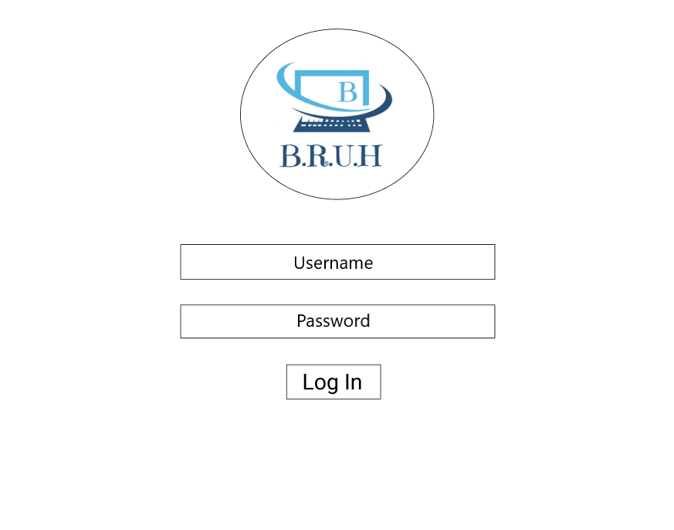

Log In Page

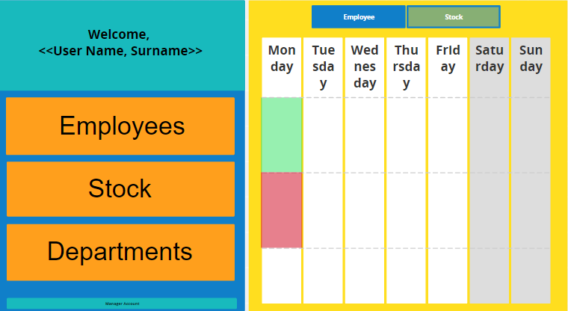The welcome page. With the employee shortcut where you see the shifts that have their employee requirement met.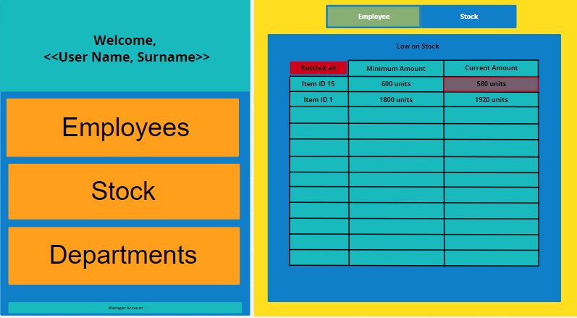

The welcome page. With the shortcut to see which products need to be restocked.

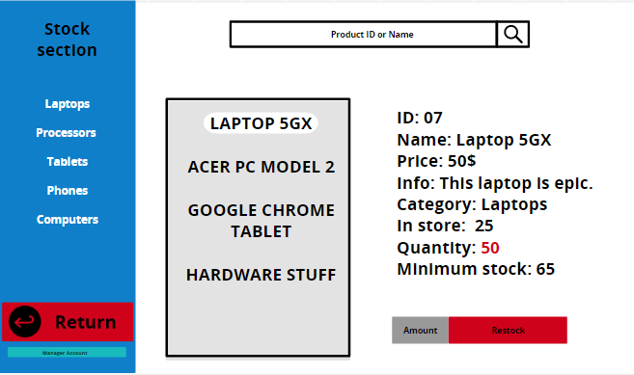

The stock section. Here you can enter a product’s ID and name to see a product’s information.

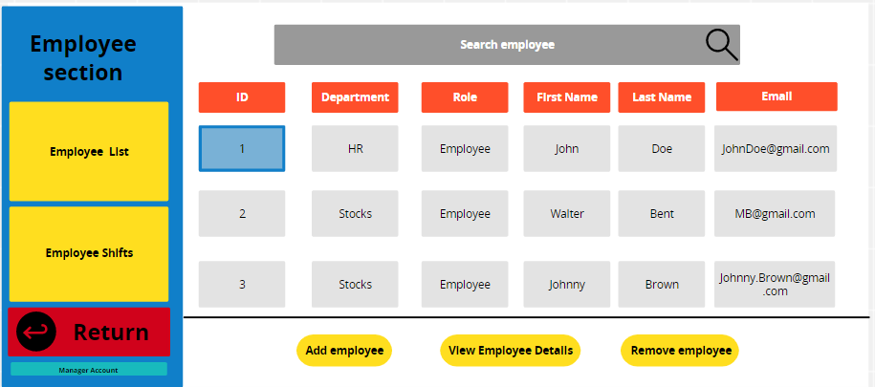

The employee section. This is where you see the employee list with some details that would be useful to the manager.

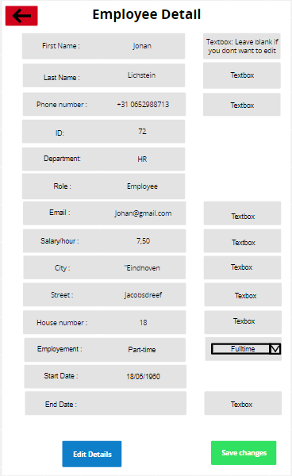

The employee detail form. This is where you can see all the employees’ details and edit them.

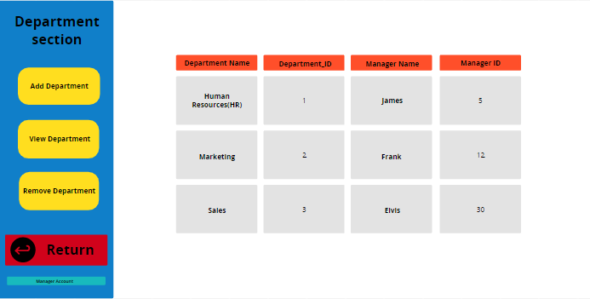

The department section. Here you see the current departments and their information such as the name and the manager’s name of that department.

# UML Class-Diagram

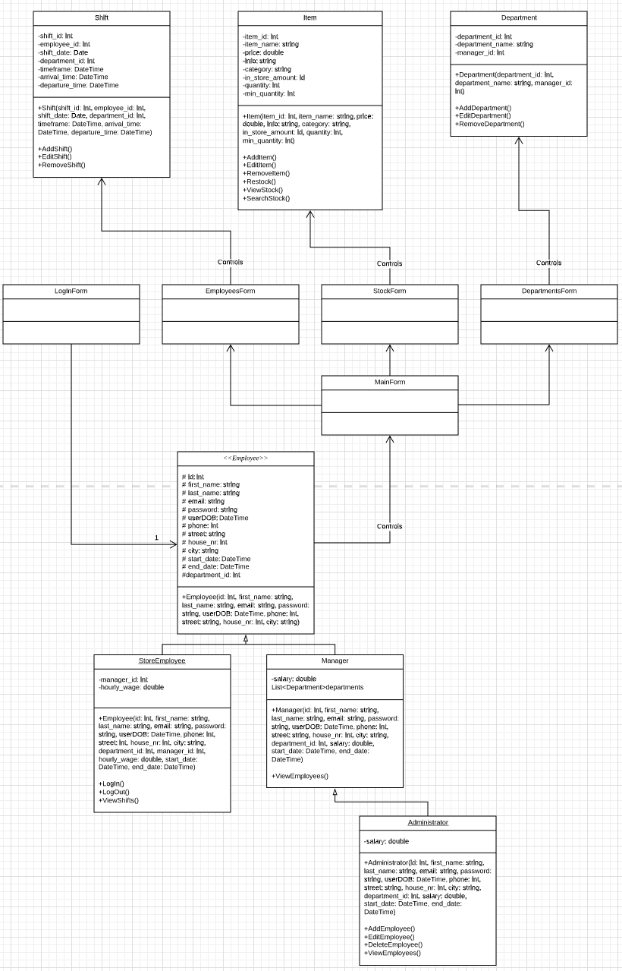

# ERD

